Elevator Series Summer Assignment (DUE FIRST DAY OF SCHOOL)

Part I: Blueprints

Objective:
The year is 1903. You are the architect of a new office building in downtown New York. You have been instructed to use the latest technology, such as elevators. Your building is to be a true marvel of the modern world with a whopping twenty-stories and three elevators. This lab should be a simulation of the elevators in the building. The program must read in a file containing a list of people on each floor. (The file represents the distribution of people calling the elevator at the start of an hour.) The information in the file must be read into an appropriate data structure. At the end of an hour, your program must output the distribution of people and the status of each elevator. Your project should be turn based (like the case study) where each “turn” represents one minute. The final project should be a class-based solution. And remember, this is 1903, so renovations are definitely in the future--make sure you have a good foundation to build upon. Keep in mind that future upgrades may include multiple elevators and multiple elevator types, so design your classes wisely.

Description:
The elevators are used throughout the day, but at different loads at any given time. The usage versus time is shown on the graph below. This shows that, for example, an elevator is more likely to be called at 9 am than at 11 am. The elevators work based on a simple algorithm (not to mention inefficient—it’s 1903, after all). When there is a call, an elevator is sent to take care of the call. The building first deals with the calls closer to the ground (i.e. a call on floor 4 gets dealt with before a call on floor 9) and, if a floor has people going both directions, the down destination gets precedence. Once it has picked up everyone whose destination agrees with the call, the elevator begins moving in the direction indicated by the calling floor. The elevator picks up and drops off people, always moving in the same direction, until it is empty. Once it is empty, the elevator becomes free and begins moving back to the bottom floor, unless there is another call. The elevator moves at a rate of one floor per minute and has a maximum capacity of six people.

Example
Say there is a man, who goes by Joe Bob, working on floor twelve of the building. It’s Friday and he’s eager to go home, so he finishes early and calls the elevator at 5 pm. When he pushes the call button, the building dispatches a non-busy elevator to the twelfth floor from the ground floor (takes 12 minutes to arrive). Once the elevator arrives, not only does Joe Bob get on, but also several other people who want to go down get on. One of them only wants to go to the tenth floor, so the elevator stops there and lets him off (takes 2 minutes), and then continues going down. It next stops at the eighth floor (takes 2 minutes) and picks up more people who want to go down. Again, at the fifth floor, the elevator stops to let people on (takes 3 minutes), but the elevator becomes full after the first one gets on. Thus, the doors slam shut on the remaining people and the elevator moves on. The fifth floor’s call button remains lit, however, and the people on that floor continue to wait. Finally, Joe Bob’s elevator reaches the bottom floor (takes 5 minutes) and releases our man and everyone else on the elevator. The elevator now becomes non-busy again. (Note, if the elevator is not at the ground floor when it becomes non-busy, it should head there, picking up passengers along the way.) And that is how the elevator should run.

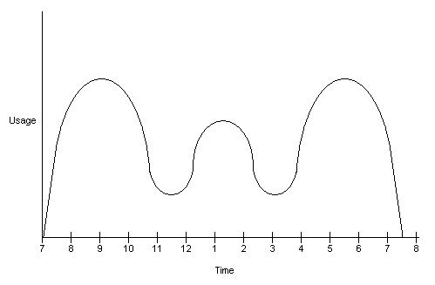
Directions
In part I of the project, you will not be coding, but will be submitting a proposal of how the program will be organized in classes. Keep in mind that you should maximize your capabilities to leverage classes for future use. You will submit three documents: a class hierarchy diagram (including is-a and has-a relationships), a sheet listing your proposed classes, each accompanied by a proposed list of methods, and a brief justification for your class design. Your proposal will be reviewed by foreman Dave and will be approved or rejected for use in construction. If your proposal is not deemed acceptable, it must be revised and resubmitted. In case you didn’t get the memo, you must include a cover page on this tps report.

Elevator Series
Part II: Construction
Directions
The year is 1907. Now that your plans have been approved, it is time to start building. You are to code the proposal you have submitted and fulfill the requirements documented in part I. Feel free to use any new techniques you have learned since completing part I. For your convenience, sample output is provided below. Try to match the output as best as possible.

Sample Final Output
(For 5pm Calls)

Floor 1: 8 person(s): Zacherelli Klein Bruno Rajat Lamikins Fung Mike Farrell
Floor 3: 1 person(s): C-Diddy
Floor 8: 2 person(s): Francis E-Dogg
Floor 12: 1 person(s): Kommunistkov

Elevator 1: Floor 1, Destination NOT MOVING, NOT ACTIVE, 0 person(s):
Elevator 2: Floor 1, Destination NOT MOVING, NOT ACTIVE, 0 person(s):
Elevator 3: Floor 1, Destination NOT MOVING, NOT ACTIVE, 0 person(s):
Total Time: 49 minute(s)

Sample Text File
Calls at 5 pm

Floor
1
2
3
5
5
8
9
9
10
12
14
19

Person
Francis
Kommunistkov
Mike
E-Dogg
Zacherelli
Bruno
Rajat
Lamikins
C-Diddy
Fung
Mike
Farrell

Destination
8
1
1
8
12
1
1
1
3
1
1
1

